Title of the Paper with Capitalization as Appropriate

A. Author¹, B. Author¹, and C. Author²

¹ emailab@address, Correspondence Address
² emailc@address, Correspondence Address

- Introduction

In the title do not use subscripts, superscripts, and special characters, such as @, #, %, & etc. and Greek letters. We request that you limit the summary between two (minimum) and four (maximum) A4 pages. To write up your extended summary, you are requested to use font Times New Roman, size 11, with single-spaced text. You need not have multiple sections.

2. Methodology

This is Section 2. Equations, such as Eq. 1, are numbered to the right of the formula

$Ω∙∇ψ+ σ_{t }\left(r\right)ψ\left(r,Ω\right)= \frac{σ_{s }\left(r\right)}{4π}\int_{4π}{dΩ^{'} ψ\left(r,Ω^{'}\right)}+Q\left(r,Ω\right)$ . | (1)

Figures, such as Fig. 1, may be included centered on the page and numbered in Arabic numerals. The caption appears below the figure.

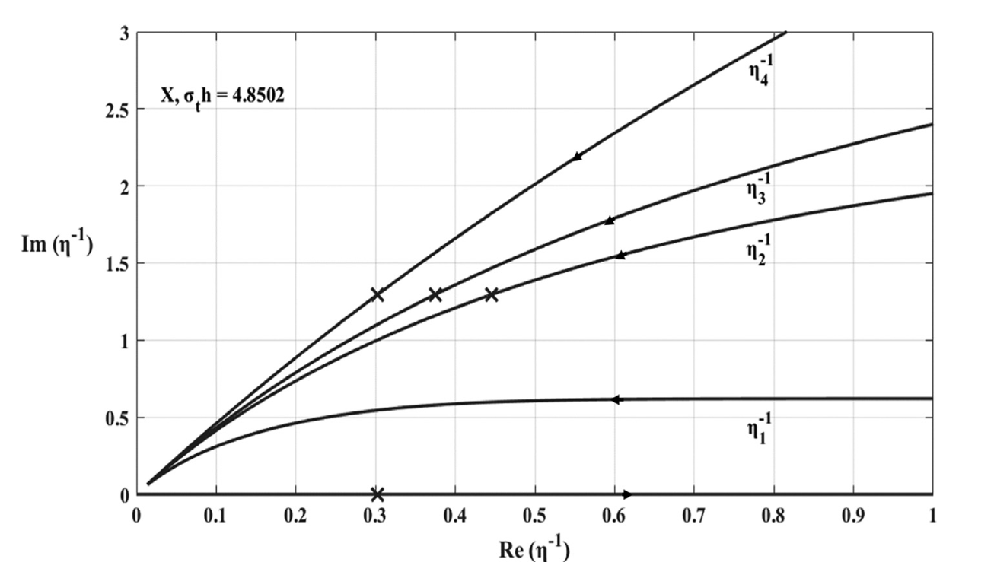

Figure 1: Positive inverse LD spectrum for N = 8 and.c₀ = 0.97.

See Table I for an example of a table. The caption appears above the table, which must be centered on the page and numbered in Roman numerals.

Table I: Scalar flux for the LD and the ELD methods using S₂ formulation in model problem 1.

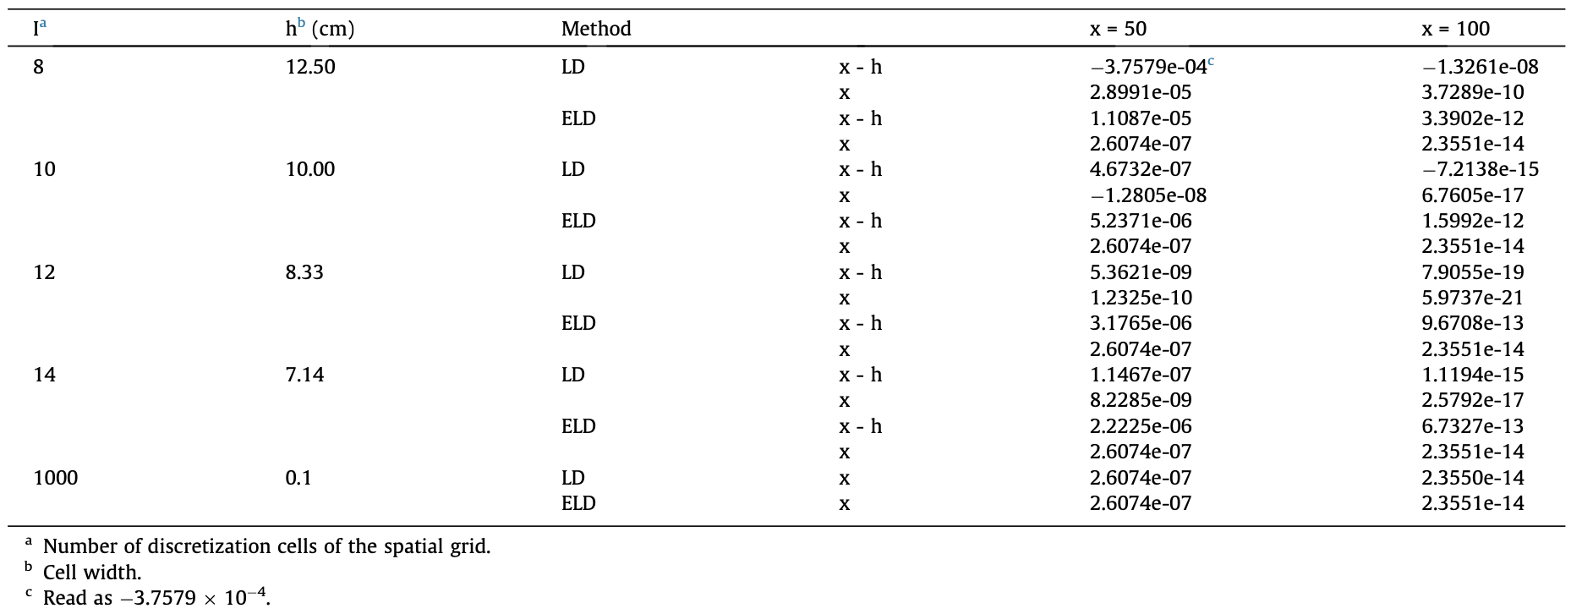

3. Results and Discussion

Here you show your results in a compact fashion and give a brief discussion.

4. Conclusions

A summary and a number of concluding remarks might go here with suggestions for future work.

Acknowledgements

The LAT_{E}X format has been prepared by Professor Helio Pedro Amaral Souto, Instituto Politécnico (IPRJ), Universidade do Estado do Rio de Janeiro (UERJ), Brazil.

References

[1] A. Author, “Article,” Journal Name, vol. 1, pp. 1–199 (2013).

[2] A. Author, “Paper,” Proceedings of Meeting, Location, Dates, vol. 1, pp. 5209–5314 (2013).
[3] A. Author, Book Title, Publisher, City & Country (2013).
[4] “A Website for Everything,” http://this.is.not.a.site/nothing (2013).

